DBMS

Assignment

Shreyansh Jain

11CSS-59

5th Semester

q1) get the title, author name, publisher name for author whose city contain total no of a=2.

select title, authname, pubname from author159 a, book159 b, wby159 c where authcity like '%a%a%' and a.authid=c.authid and b.bookid=c.bookid;

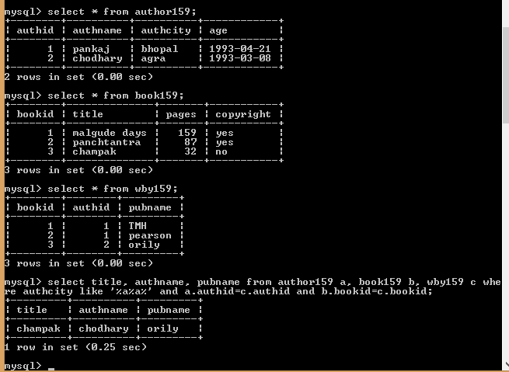

q2) give the details of the book which is written by at least two authors.

select \* from book159 where bookid in (select bookid from wby159 group by bookid having count(\*)>=2);

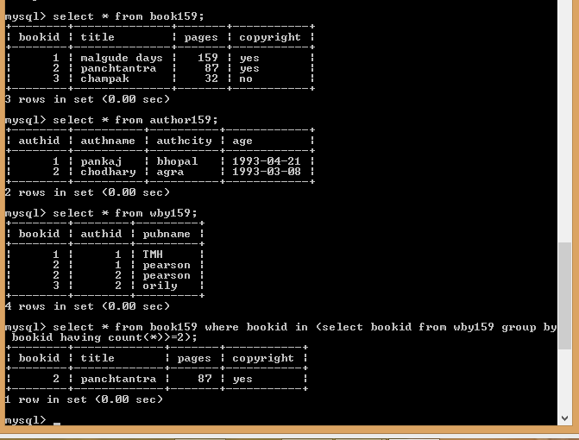

q3) write a stored procedure (insertintoauth) to insert the author information.

create function agevalidate159(ag date) returns int

begin

declare diff int;

set diff=Datediff(sysdate(),ag);

if diff>6575 and diff<21915 then

return 1;

else

return 0;

end if;

end#

create procedure insertintoauth159(in id int,name varchar(20),city varchar(20),age date)

begin

declare c int;

set c=(select count(\*) from author159 where authid=id);

if c>0 then

select 'Author ID already exists';

else

if agevalidate159(date) =1 then

insert into author159 values(id,name,city,age);

else

select 'Condition Not Satisfied';

end if;

end if;

end#

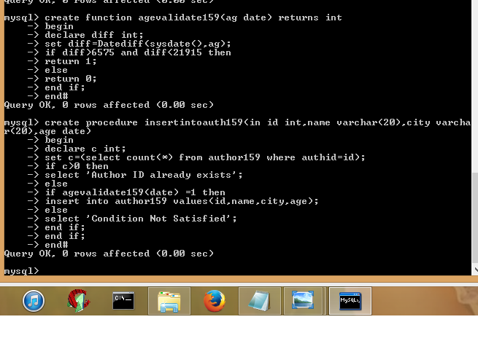

q4) write a stored procedure (insertbookinfo) to insert the book informaton such as bookid, title, no of pages, copyright, authorid, publisher name.

create procedure insertwby159(in bid int, id int, pbname varchar(20))

begin

insert into wby159 values(bid,id,pbname);

end#

create procedure insertbook159(in bid int, cp varchar(5), title varchar(20), pages int, id int, pbname varchar(20))

begin

declare ct int;

set ct=(select count(\*) from book159 where bookid=bid);

if ct>0 then

select 'Book ID already exists';

else

insert into book159 values(bid,title,pages,cp);

call insertwby159(bid,id,pbname);

end if;

end#

create procedure insertbookinfo159(in bid int, title varchar(20), pages int, cp varchar(5), id int, pbname varchar(20))

begin

declare ct int;

set ct=(select count(\*) from author159 where authid=id);

if ct=0 then

select 'ERROR';

else

call insertbook159(bid,cp,title,pages,id,pbname);

end if;

end#

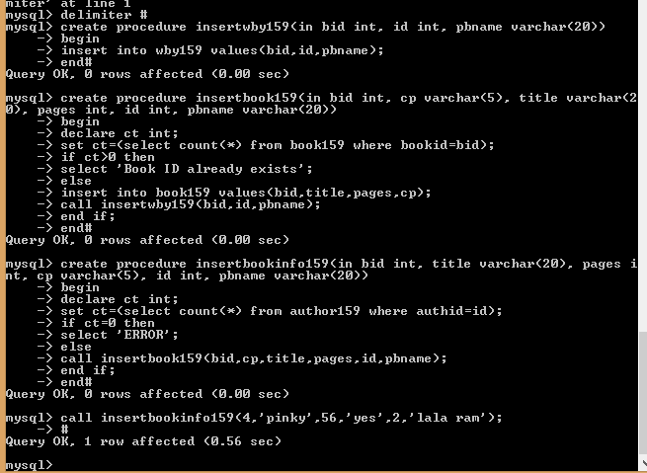

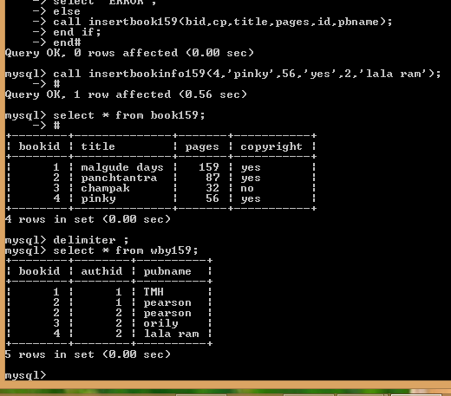

q5) write a stored procedure to delete the author information using its authid.

create procedure delauthor159(in id int)

begin

declare ct int;

declare str varchar(100) default "";

set ct=(select count(\*) from wby159 where authid=id);

if ct>0 then

set str=concat(str,"You can't delete Author because total ",ct," book exist in table book159. First delete all the books written by him");

select str as "ERROR";

else

delete from author159 where authid=id;

end if;

end#

q6) write a stored procedure to delete the book using authid.

create procedure delbook159(in id int)

begin

declare bid int;

declare i int;

set i=(select count(\*) from wby159 where authid=id);

myloop:loop

if i>0 then

set i=i-1;

set bid=(select bookid from wby159 where authid=id limit i,1);

delete from book159 where bookid=bid;

iterate myloop;

else

leave myloop;

end if;

end loop myloop;

end#

